1. 
2. In the previous lecture, we saw **Mutate Filter Plugin**, but there are a number of other **filter plugins**.
3. **Logstash** contains a handful of so-called **common options**.  
   These options are general in nature and therefore related to any specific **filter** **plugin.**
4. These common options are configured in the same way we configured option **“convert”** in the **Mutate Filter Plugin** in previous lecture.
5. These options can be used from any of the **filter plugins** hence the name **Filter Plugins.**
6. **Common Filter Options:**A picture containing text, screenshot, font, number

   Description automatically generated

We already saw the tags when talked about **JSON Codec** to handle **invalid JSON**.

**add_tag**: can be useful to tag an event and thereafter to perform some conditional processing on events depending on which tags the event contain.  
That is something we will see later in this course.

1. A picture containing text, multimedia software, software, graphics software

   Description automatically generated
2. 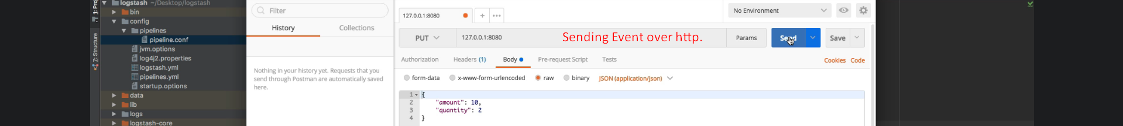
3. A screenshot of a computer

   Description automatically generated with medium confidence
4. The common option **“remove_field”** is useful in case we don’t want some fields to be part of the output.  
   For example, we may not be interested in headers field in the output what output we have defined.
5. In the similar way, other common options can be used. There is not special ways for them.